**EECS 331: Introduction to Computational Photography**

HW5: Depth from Focus

1. **Implement an Android function to capture a focal stack**

Android program ‘backbone’ was modified to fulfil the given conditions.

Minimum Focal Distance of Tegra: 0.666 D

Maximum Focal Distance of Tegra: 10 D

Focal Stack was captured with 27 images in it:

The following are a few images in the stack:





Fig 0: Samples of chosen scene

1. **Calibrate the focal stack**

Focal stack was calibrated based on the lens function.

1. **Compute depth map of the image**

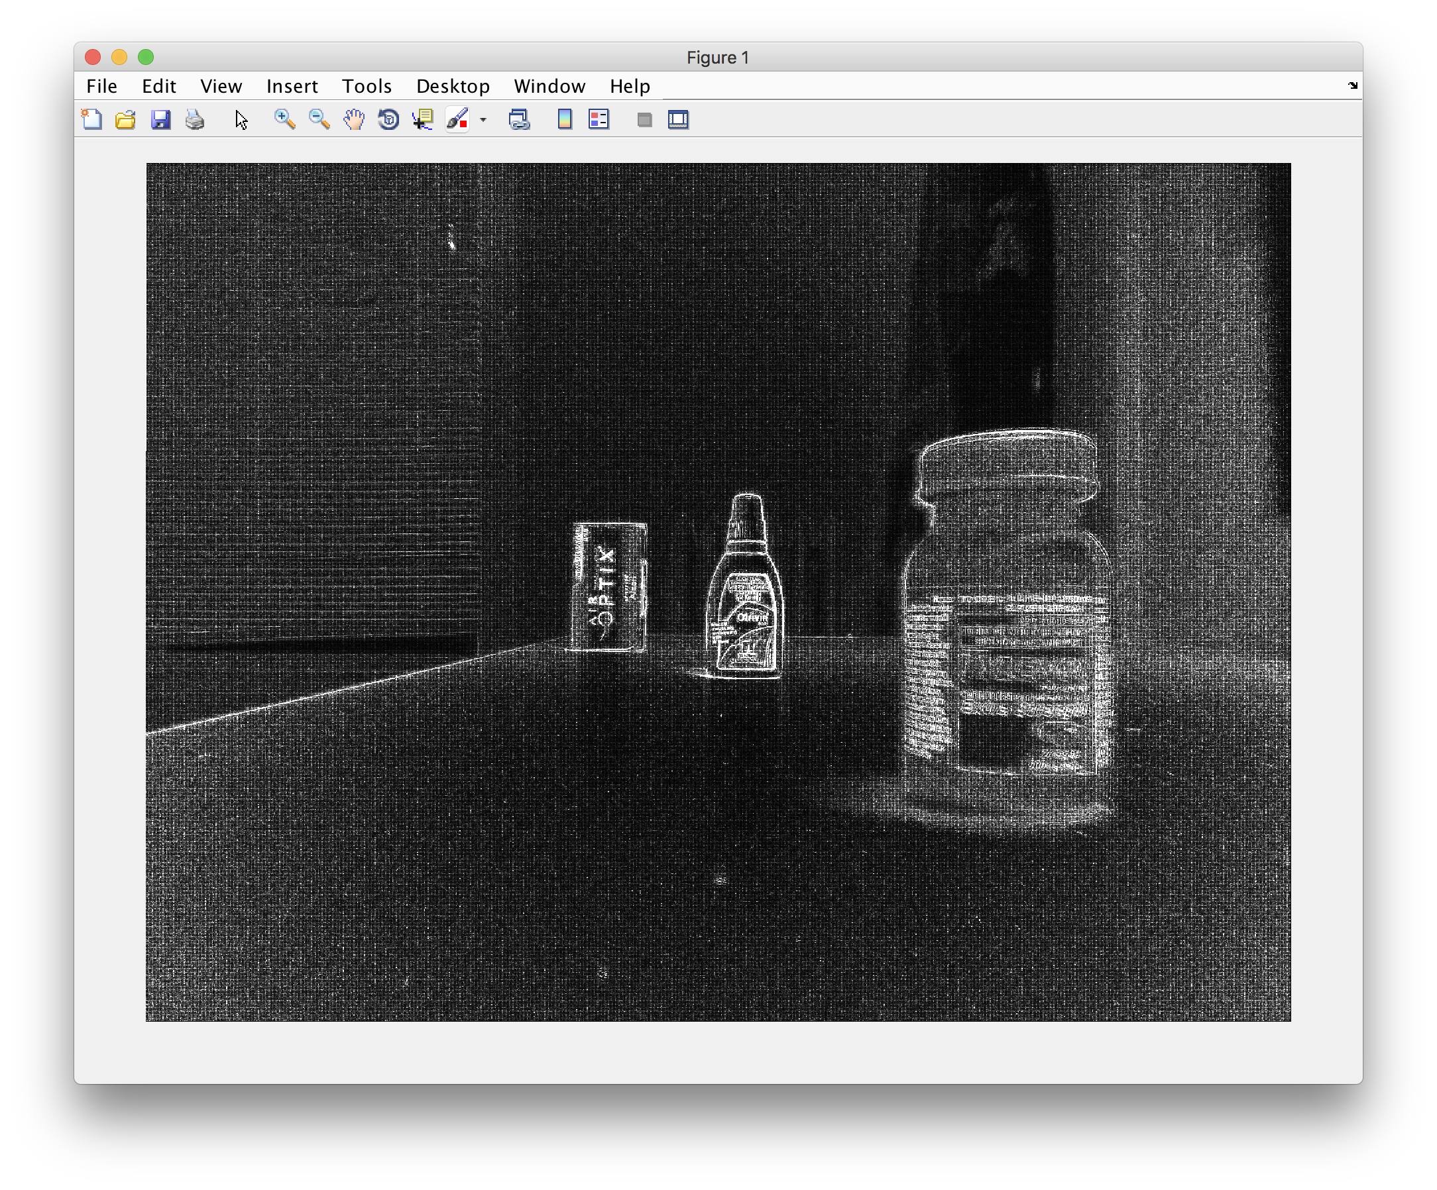

Value of K chosen = 5

Value of K depends on the amount of texture.

Lower values when amount of texture is high.

1. **Recover an all focus image:**

All focus image recovered from the depth map. Highest pixel value was computed out of all 27 images and applied from depth map to form the final image.

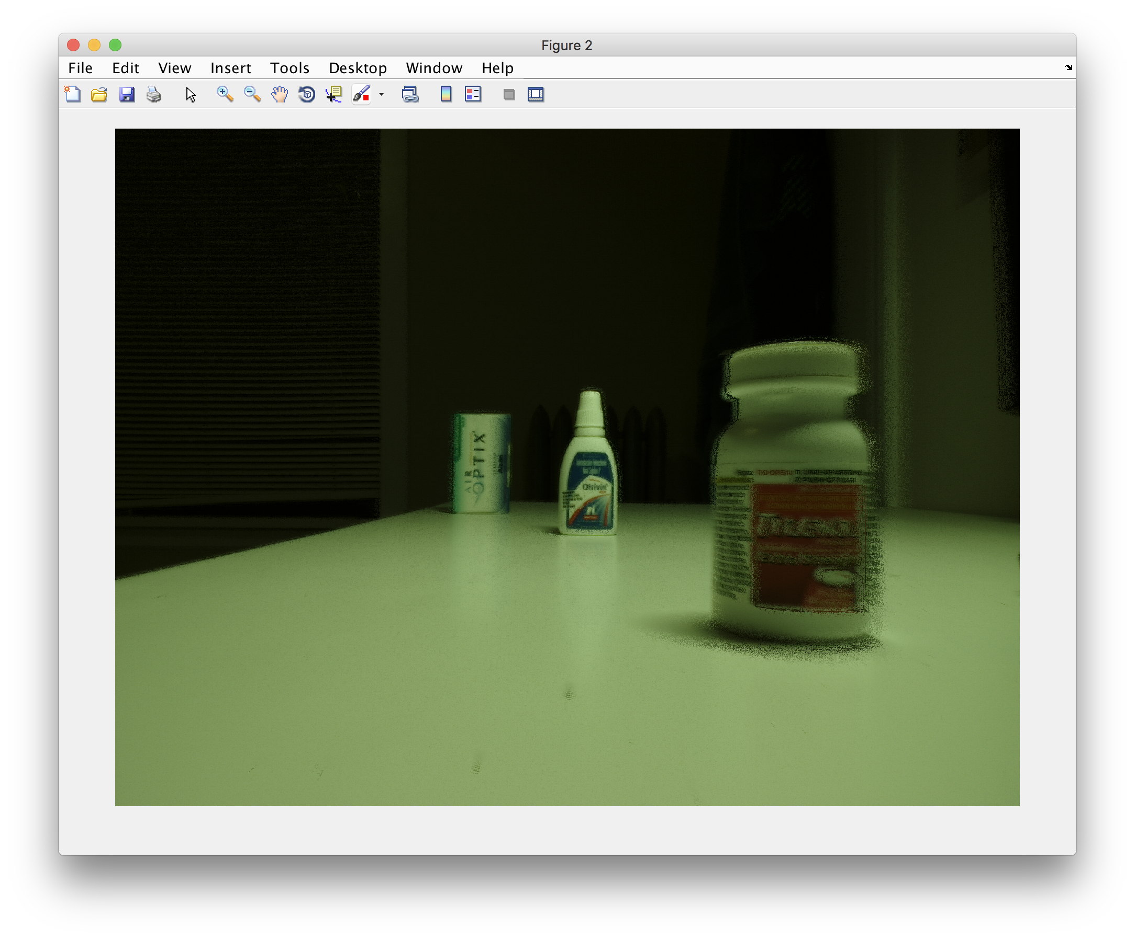

Although in focus, there clearly seems to be texture leak in the above image. My images weren’t highly textured as asked in the question.